Weekly Newsletter
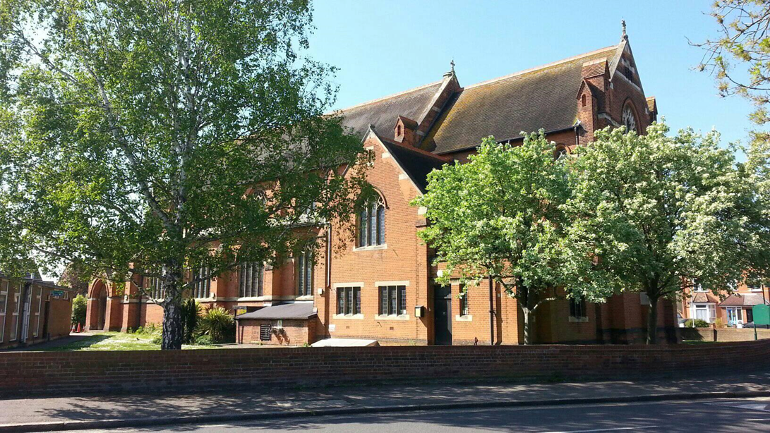
Photo courtesy of Chris Maddock

Welcome to the first edition of our weekly newsletter.
The 9.30am Sunday Eucharist can be viewed via our Facebook page and our new YouTube channel (St Hilda’s Ashford). Please see our website (www.sthilda.org) for updates and the weekly service sheet.

Contents

Daily Hope – The Archbishop of Cantebury’s recently lauched free telephone line for worship, pray and reflection.

Quiet, Brave, Endurance – Paul Handley writes (Church Times 27.4.2020)

St Hilda’s Outreach – Sleeping bag appeal

Our thoughts and prayers – Those from this weeks notices

If you would like help or to speak to a member of the ministry team please contact the office on 01784 253525 or office@sthilda.org Father Joseph can be contacted on 01784 254237.
Daily Hope has been available since Sunday and runs for 24 hours a day. It provides Church of England prayers, hymns, and reflections for those who dial in. The number is 0800 8048044.
Churches have been providing more services online since public worship was suspended, owing to the coronavirus pandemic (News, 27 March; Online Comment, 18 April). Many older people lack internet access, however: figures published by the Office for National Statistics show that 2.5 million aged 75 or over have never used the internet.
The Church of England is providing the service jointly with the Christian charity Faith in Later Life, which seeks to reach out to older people who are isolated or lonely; and Connections, a regular gathering of older people at Holy Trinity, Claygate, in Surrey, which, before Covid-19, hosted 150 guests each week.
Those who phone Daily Hope will first hear a greeting from Archbishop Welby before being offered a range of prayers, hymns, and liturgy, including the Church of England’s weekly national online service, and advice about the coronavirus.

Archbishop Welby said: “I want to urge people to spread the news about this service. If there is someone you know who is particularly struggling, give them a call and let them know about the Daily Hope. I’m going to phone a friend; will you join me?”

The chief executive of Faith in Later Life, Carl Knightly, said: “We know as an organisation of the challenges for older people in our society in normal times, and these are not those; so I want to add our voice to that of the Archbishop and get people sharing this number with whoever they know who would most benefit.” Church Times, 27th April 2020
A prayer for midday

BREATHE on me, Spirit of God.
Awaken me to this moment of daylight’s height that points to the light of your Son that is with me.
Breathe on me, Spirit of God, as I spread my hands before you, holding in them the lost, the desperate, and the dying, holding those you have given me to love in my praying, holding in them my joys, my hopes, and my sorrows.
Let the eyes of Christ be fixed upon me and those for whom I pray.
As I rest for this brief moment, breathe, Spirit of refreshment, on all of me, that I may be drawn ever deeper into walking with the Son of Pilgrimage, by whose love I move and pray and delight in God.
Amen.
(Anon.)

Quiet, brave endurance.
RESIGNATION is an under-valued virtue, writes Paul Handley. Indeed, among young people it might not be a virtue at all. It would be disappointing if the next generation simply put up with things as they found them.
In later life, however, people have a better grasp of what can be changed and what must be endured. It is perhaps surprising that endurance is praised when someone goes out and seeks it for sport. It is unnoticed when practised by countless people in the quiet of their daily lives.
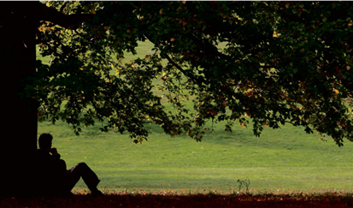
One of the most moving examples of this that I have come across recently — moving because so modestly and simply expressed — is a passage in The Last Wilderness, by Neil Ansell (Tinder Press, 2018). The book relates the writer’s visits to a remote area on the west coast of Scotland. On one occasion, far from help, he suffers the pain of a worsening heart condition:
“WE ALL get ill, at some time or another, sooner or later. When it comes to our own decline, it is never a matter of if, only of when. And we all have to work within the confines of our own physical limitations. If I could no longer climb a mountain, then I would climb a hill. And if the only thing that was still a walk in the park was an actual walk in the park, then I would find a park. And when the time came that I could do nothing more than look out of a window, then I hope I would have chosen for myself a room with a view worth watching.

“I had no complaints; I felt privileged and fortunate to have been born in a time and a place where most of the hardships I had endured and wounds I had suffered were, in large part, the consequence of decisions that I had freely made. I had never been compelled to go to war, and I had never been forced to flee my homeland for my own survival. I’d had the freedom to roam the world without the use of force; mostly I had been made welcome wherever I had found myself.

“Generations of people throughout history, and many people now, have had to live out their lives without these luxuries, without peace, without almost guaranteed access to enough food, or clean water, or medicines.
“My health might apparently be abandoning me, but I was able to be here, sitting under my tree in this most beautiful of spots, and I was grateful.” Church Times, 27th April 2020

Spelthorne Council VE Day 75th Anniversary Civic Service

The civic service will be on the Spelthorne Council website from 3pm on 8th May 2020.

Crossroads
Please email Rosemary at crossroads_ashford@hotmail.com if you have anything to be included in the parish magazine. The most recent edition is available on our website.

Hebrews 10:24-25

“And let us consider how we may spur one another on toward love and good deeds, not giving up meeting together, as some are in the habit of doing, but encouraging one another—and all the more as you see the Day approaching.”

Appeal for sleeping bags and tents
St Hilda is committed to help those who find themselves homeless, for whatever reason, by providing sleeping bags and tents. So far it has relied on donations from the local community, but due to Covid-19 it has run out. Although more invisible than ever, homelessness has not gone away. If you have some which you no longer need, or are able to make a donation to purchase new ones, please do get in touch. It is a small step for one person, but a big step for our community, to pull together in order to help those who do not have the security of a place to stay. Thank you so much in advance.

Please hold in your prayers and thoughts this week those who are affected by the Corona Virus as well as the family and friends of those below.

The Sick
James Bedford | Margaret Kerr | Elsie Stone
Pamela Claridge | Libby Mills | Roy Stone
Robb Clarke | Raymond Nation | Sandra Swain
Ann Considine | Michael O’Hagan | Rev. Peter Taylor
Michael Dixon | Elizabeth Savill-Burgess | Chick Wilson
Dennis Goff | Delphine Scrivener | Peter Wilson
Jim Hennessey | Riley Shaw | Jo Wood
Penny Howell | Anne Shenton | Nic
The Recently Departed
Richard | Beverly | Irene | Elizabeth Connor
Patricia Pouffou | Ronald Cobb | David Ibbotson | Mary Berry
George Brown | Donna Marshall | Christine Brown

