St Hilda’s Ashford

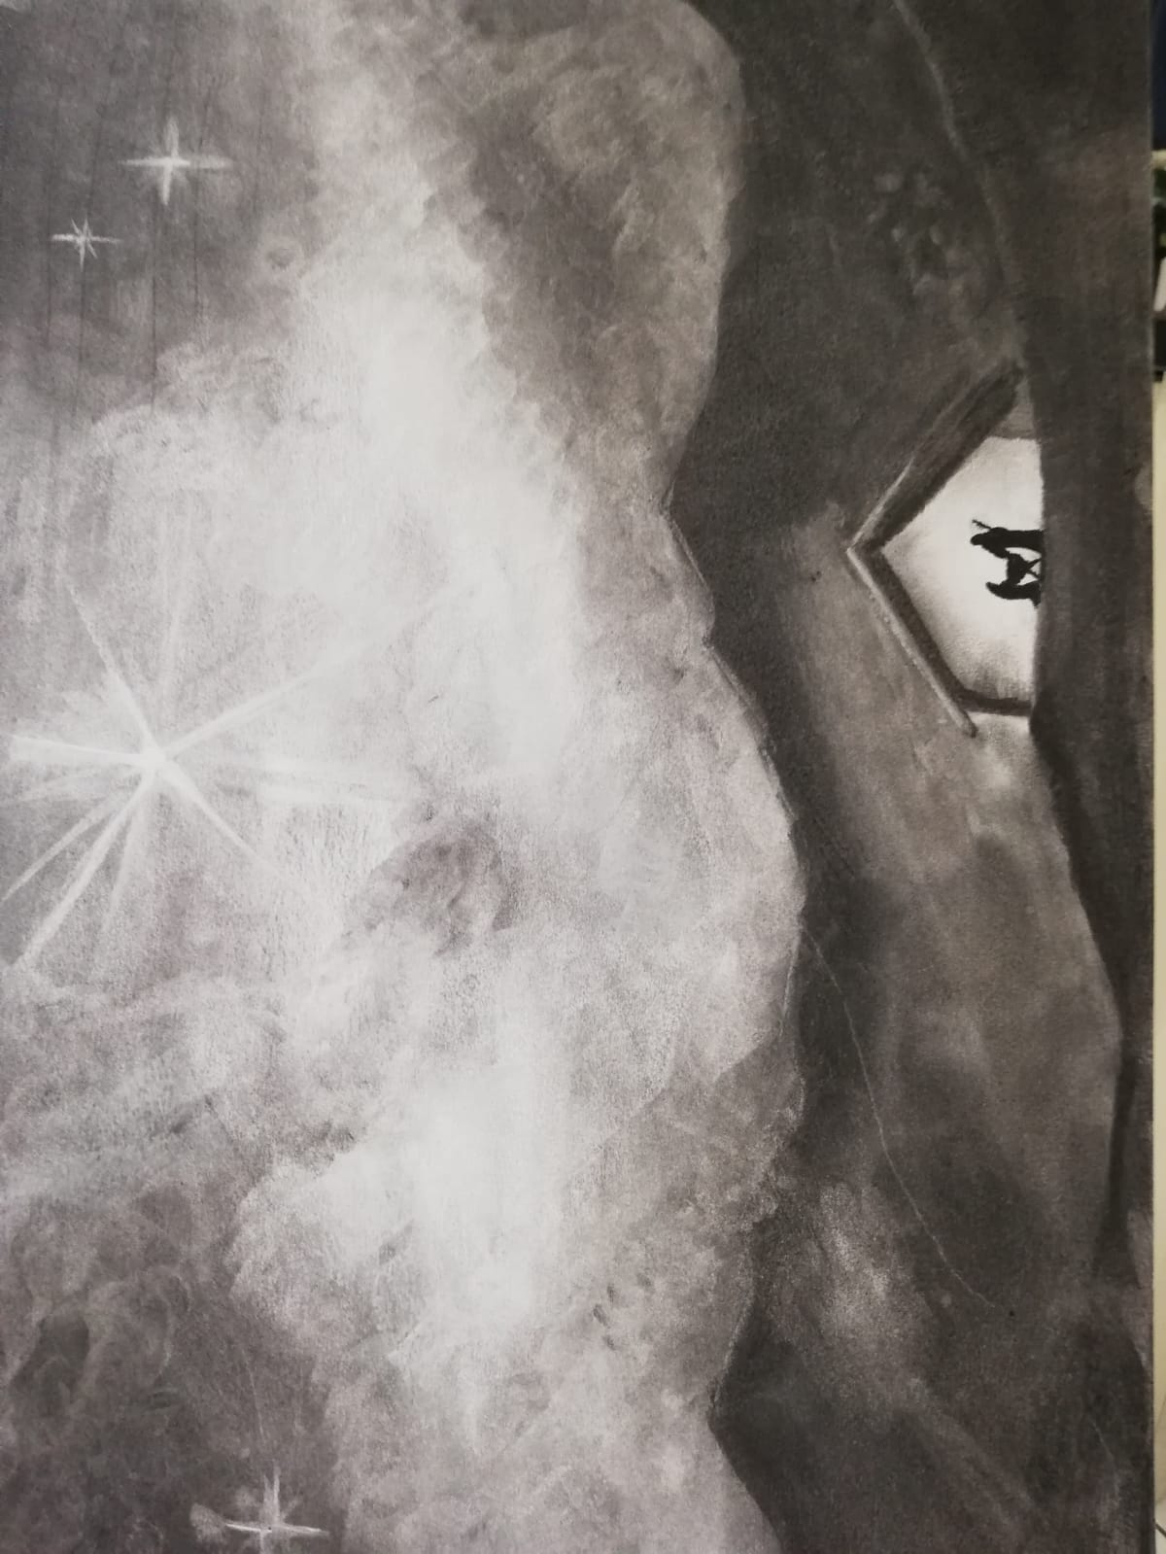

The Midnight Mass of Christmas

Welcome to St Hilda’s Ashford for our traditional Midnight Mass of Christmas

This service is held at night in line with the Western Christian tradition that Jesus was born during the night. From early Jewish times, it was held that the day began in the evening, and to this day in modern Christian liturgy, the Office of Evening Prayer is the first act of worship of the day.

This is a service of great joy and celebration when we do two distinct things: first, we celebrate the historical account when we greet Jesus and the Holy Family in his stable. Secondly, we commemorate the spiritual significance of God’s Incarnation into human form as the means of our Salvation. We therefore bless the crib at the start of the service, and then we hear the words of John’s Gospel at the end to connect these two aspects of our celebration.

Eternal God,
in the stillness of this night
you sent your almighty Word
to pierce the world’s darkness with the light of salvation:
give to the earth the peace that we long for
and fill our hearts with the joy of heaven
through our Saviour, Jesus Christ.

All stand as the minister enters the church.

The Greeting

Grace, mercy and peace
from God our Father
and the Lord Jesus Christ
be with you.
All and also with you.

Blessing of the Crib – all sit

Dear friends, as we meet to celebrate the birth of Christ, let us pray that God will bless this crib, that all who worship his Son, born of the Virgin Mary, may come to share his life in glory.
God our Father,
on this night
your Son Jesus Christ was born of the Virgin Mary
for us and for our salvation:
bless this crib,
which we have prepared to celebrate that holy birth;
may all who see it be strengthened in faith
and receive the fullness of life he came to bring,
who is alive and reigns for ever.
All Amen.

Prayers of Penitence – we sit or kneel for our prayers

Christ the Light of the world has come
to dispel the darkness of our hearts.
Let us turn to the light and confess our sins.
[Silence is kept]
God our Father,
you sent your Son full of grace and truth:
forgive our failure to receive him.
Lord, have mercy.
Lord, have mercy.
Jesus our Saviour,
you were born in poverty and laid in a manger:
forgive our greed and rejection of your ways.
Christ, have mercy.
Christ, have mercy.
Spirit of Love,
your servant Mary responded joyfully to your call:
forgive the hardness of our hearts.
Lord, have mercy.
Lord, have mercy.
May the God of all healing and forgiveness
draw you to himself,
that you may behold the glory of his Son,
the Word made flesh,
and be cleansed from all your sins
through Jesus Christ our Lord. Amen.

Gloria in Excelsis – All stand

Glory to God in the highest,

and peace to his people on earth.

Lord God, heavenly King,

Almighty God and Father,

we worship you, we give you thanks,

we praise you for your glory.

Lord Jesus Christ, only Son of the Father,

Lord God, Lamb of God,

you take away the sin of the world:

have mercy on us;

you are seated at the right hand of the Father:

receive our prayer.

For you alone are the Holy One,

You alone are the Most High, Jesus Christ,

with the Holy Spirit,

in the glory of God the Father.

Amen.

The Collect

Almighty God,

as we prepare with joy

to celebrate the gift of the Christ-child,

embrace the earth with your glory

and be for us a living hope

in Jesus Christ our Lord.

Amen.
First Reading - Isaiah 9: 2-7

The people who walked in darkness
have seen a great light;
those who lived in a land of deep darkness—
on them light has shined.
You have multiplied the nation,
you have increased its joy;
they rejoice before you
as with joy at the harvest,
as people exult when dividing plunder.
For the yoke of their burden,
and the bar across their shoulders,
the rod of their oppressor,
you have broken as on the day of Midian.
For all the boots of the tramping warriors
and all the garments rolled in blood
shall be burned as fuel for the fire.
For a child has been born for us,
a son given to us;
authority rests upon his shoulders;
and he is named
Wonderful Counselor, Mighty God,
Everlasting Father, Prince of Peace.
His authority shall grow continually,
and there shall be endless peace
for the throne of David and his kingdom.
He will establish and uphold it
with justice and with righteousness
from this time onward and forevermore.
The zeal of the Lord of hosts will do this.

At the end the reader says
This is the word of the Lord.
All Thanks be to God.

Second Reading - Titus 2: 11-14

For the grace of God has appeared, bringing salvation to all, training us to renounce impiety and worldly passions, and in the present age to live lives that are self-controlled, upright, and godly, while we wait for the blessed hope and the manifestation of the glory of our great God and Savior, Jesus Christ. He it is who gave himself for us that he might redeem us from all iniquity and purify for himself a people of his own who are zealous for good deeds.

At the end the reader says
This is the word of the Lord.
All Thanks be to God.
Gospel Reading – Luke 2: 1-20
Alleluia, alleluia.
The Word became flesh and dwelt among us,
and we have seen his glory.
Alleluia.
Hear the Gospel of our Lord Jesus Christ according to Luke.
All Glory to you, O Lord.

In those days a decree went out from Emperor Augustus that all the world should be registered. This was the first registration and was taken while Quirinius was governor of Syria. All went to their own towns to be registered. Joseph also went from the town of Nazareth in Galilee to Judea, to the city of David called Bethlehem, because he was descended from the house and family of David. He went to be registered with Mary, to whom he was engaged and who was expecting a child. While they were there, the time came for her to deliver her child. And she gave birth to her firstborn son and wrapped him in bands of cloth, and laid him in a manger, because there was no place for them in the inn.
In that region there were shepherds living in the fields, keeping watch over their flock by night. Then an angel of the Lord stood before them, and the glory of the Lord shone around them, and they were terrified. But the angel said to them, “Do not be afraid; for see—I am bringing you good news of great joy for all the people: to you is born this day in the city of David a Saviour, who is the Messiah, the Lord. This will be a sign for you: you will find a child wrapped in bands of cloth and lying in a manger.” And suddenly there was with the angel a multitude of the heavenly host, praising God and saying,
“Glory to God in the highest heaven,
and on earth peace among those whom he favours!”
When the angels had left them and gone into heaven, the shepherds said to one another, “Let us go now to Bethlehem and see this thing that has taken place, which the Lord has made known to us.” So they went with haste and found Mary and Joseph, and the child lying in the manger. When they saw this, they made known what had been told them about this child; and all who heard it were amazed at what the shepherds told them. But Mary treasured all these words and pondered them in her heart. The shepherds returned, glorifying and praising God for all they had heard and seen, as it had been told them.

At the end of the Gospel reading,
This is the Gospel of the Lord.
All Praise to you, O Christ.

Sermon - All sit

The Creed – All stand

All We believe in one God,
the Father, the Almighty,
maker of heaven and earth,
of all that is,
seen and unseen.
We believe in one Lord, Jesus Christ,
the only Son of God,
eternally begotten of the Father,
God from God, Light from Light,
true God from true God,
begotten, not made,
of one Being with the Father;
through him all things were made.
For us and for our salvation he came down from heaven,
was incarnate from the Holy Spirit and the Virgin Mary and was made man.
For our sake he was crucified under Pontius Pilate;
he suffered death and was buried.
On the third day he rose again
in accordance with the Scriptures;
he ascended into heaven
and is seated at the right hand of the Father.
He will come again in glory to judge the living and the dead,
and his kingdom will have no end.
We believe in the Holy Spirit,
the Lord, the giver of life,
who proceeds from the Father and the Son,
who with the Father and the Son is worshipped and glorified,
who has spoken through the prophets.
We believe in one holy catholic and apostolic Church.
We acknowledge one baptism for the forgiveness of sins.
We look for the resurrection of the dead,
and the life of the world to come.
Amen.

Prayers of Intercession – We sit or kneel as we pray
In peace let us pray to the Lord.

At the end the reader may say
Merciful Father,
All accept these prayers for the sake of your Son,
our Saviour Jesus Christ.
Amen.

The Peace
Unto us a child is born, unto us a son is given,
and his name shall be called the Prince of Peace.
The peace of the Lord be always with you
All and also with you.
Let us offer one another a sign of peace.
All may exchange a sign of peace.

Preparation of the Table

With this bread that we bring

All we shall remember Jesus.

With this wine we bring

All we shall remember Jesus.

Bread for his body,

wine for his blood,

gifts from God to his table we bring.

All we shall remember Jesus.

The Eucharistic Prayer
The Lord be with you
All and also with you.
Lift up your hearts.
All We lift them to the Lord.
Let us give thanks to the Lord our God.
All It is right to give thanks and praise.
All glory and honour be yours always and everywhere,
mighty creator, ever-living God.
We give you thanks and praise for your Son,
our Saviour Jesus Christ,
who for love of our fallen race humbled himself,
was born of the Virgin Mary by the power of your Spirit,
and lived as one of us.
In this mystery of the Word made flesh
you have caused his light to shine in our hearts,
to give knowledge of your glory in the face of Jesus Christ.
In him we see our God made visible
and so are caught up in the love of the God we cannot see.
Therefore with all the angels of heaven
we lift our voices to proclaim the glory of your name
and sing our joyful hymn of praise:

All Holy, holy, holy Lord,
God of power and might,
heaven and earth are full of your glory.
Hosanna in the highest.
Blessed is he who comes in the name of the Lord.
Hosanna in the highest.

Lord, you are holy indeed, the source of all holiness;
grant that by the power of your Holy Spirit ,
and according to your holy will,
these gifts of bread and wine
may be to us the body and blood of our Lord Jesus Christ;
who, in the same night that he was betrayed,
took bread and gave you thanks;
he broke it and gave it to his disciples, saying:
Take, eat; this is my body which is given for you;
do this in remembrance of me.
In the same way, after supper
he took the cup and gave you thanks;
he gave it to them, saying:
Drink this, all of you;
this is my blood of the new covenant,
which is shed for you and for many for the forgiveness of sins.
Do this, as often as you drink it,
in remembrance of me.
Great is the mystery of faith
All Christ has died:
Christ is risen:
Christ will come again.

And so, Father, calling to mind his death on the cross,
his perfect sacrifice made once for the sins of the whole world;
rejoicing in his mighty resurrection and glorious ascension,
and looking for his coming in glory,
we celebrate this memorial of our redemption.
As we offer you this our sacrifice of praise and thanksgiving,
we bring before you this bread and this cup
and we thank you for counting us worthy
to stand in your presence and serve you.
Send the Holy Spirit on your people
and gather into one in your kingdom
all who share this one bread and one cup,
so that we, in the company of all the saints,
may praise and glorify you for ever, through Jesus Christ our Lord; by whom, and with whom, and in whom, in the unity of the Holy Spirit, all honour and glory be yours, almighty Father,
for ever and ever.
All Amen.

The Lord’s Prayer

Rejoicing in the presence of God here among us,
And as our Saviour taught us, so we pray:
All Our Father, who art in heaven,
hallowed be thy name;
thy kingdom come;
thy will be done;
on earth as it is in heaven.
Give us this day our daily bread.
And forgive us our trespasses,
as we forgive those who trespass against us.
And lead us not into temptation;
but deliver us from evil.
For thine is the kingdom,
the power and the glory,
for ever and ever.
Amen.

Breaking of the Bread
The president breaks the consecrated bread.
We break the bread of life,
and that life is the light of the world.
All God here among us,
light in the midst of us,
bring us to light and life.

Agnus Dei
All Lamb of God,
you take away the sin of the world,
have mercy on us.
Lamb of God,
you take away the sin of the world,
have mercy on us.
Lamb of God,
you take away the sin of the world,
grant us peace.
Giving of Communion
The president says the invitation to communion
Christ is the true bread which has come down from heaven.
All Lord, give us this bread always.

The people and president receive communion.

At St Hilda’s, we welcome communicant members of all churches to receive Holy Communion. Alternatively, you are invited to receive a personal blessing. If you would like a blessing, please cross your arms over your chest to help us know your intention. Come one, come all!

Prayer after Communion
Eternal God, for whom we wait,
you have fed us with the bread of eternal life:
keep us ever watchful,
that we may be ready to stand before the Son of man,
Jesus Christ our Lord.

All Almighty God,
we thank you for feeding us
with the body and blood of your Son Jesus Christ.
Through him we offer you our souls and bodies
to be a living sacrifice.
Send us out
in the power of your Spirit
to live and work
to your praise and glory.
Amen.

Blessing
May the Father,
who has loved the eternal Son
from before the foundation of the world,
shed that love upon you his children.
Amen.
May Christ,
who by his incarnation gathered into one
things earthly and heavenly,
fill you with joy and peace.
Amen.
May the Holy Spirit,
by whose overshadowing Mary became the God-bearer,
give you grace to carry the good news of Christ.
Amen.
A president says
Go in peace. Proclaim the Word made flesh.
Glory, thanks and praise to God.
The ministers and people depart.

Wishing you, your family and friends a safe and blessed Christmas and a promising 2021.

Copyright Acknowledgement
©The Archbishops’ Council 2000

Cover illustration by Andrew Milton

Contacts
Vicar
Fr Joseph Fernandes
Vicar@sthilda.org Parish Office 01784 253525
Vicarage 01784 254237 Mobile 07999 053433

Licenced Lay Ministers
Carolyn Clark Carolyn@sthilda.org
Rosalyn Young rosalyn@sthilda.org

Mail & Phone via Parish Office [01784 253525]

Churchwardens
Bobbie Bedford and Frances Forsbrey
Mail & Phone via Parish Office [01784 253525] office@sthilda.org

PCC Secretary
Denise Buttigieg
Mail & Phone via Parish Office [01784 253525] office@sthilda.org

Parish Administrator
Denise Buttigieg 01784 253525 office@sthilda.org

Church Hall Bookings
Please contact the Parish Office

The Parish Office:
St Hilda's Church, Stanwell Road, Ashford, Middlesex
TW15 3QL

Telephone 01784 253525 Charity Number 1134119

CCLI: 708985

Follow us on Facebook https://www.facebook.com/StHildaAshford/
Follow us on Twitter https://twitter.com/StHildaAshford

